Meet and Greet Ride FAQ & Itinerary 2025

Dates November 7th & 8th (optional early check in 11/6/25 see below)

www. meetandgreetride.com

General Questions: (prints best in landscape)

**What is the Fall Meet and Greet Ride?**

* Gather your crew and hit the trails! The Fall Meet and Greet Ride welcomes 4x4 enthusiasts of all backgrounds for 2 days of guided exploration near the majestic Red River Gorge in Kentucky. Whether you're a newbie navigating your first dirt road or a seasoned off-road warrior we have multiple options to match to your rigs capabilities as well as your own comfort level. This is more than just a ride; it's a chance to connect with fellow adventurers and create lasting memories under Kentucky's autumn sky.
* This event welcomes any make and model street-legal, licensed vehicle with a 4wd low-range transfer case. (such as those made by but not limited too: Ford, Toyota, Jeep, GM, Dodge, Nissan, Land Rover, and others). Unfortunately, Side-by-sides and similar machines will have to sit this one out for now.
* Don't miss the Friday night sponsor raffle where you can win some epic prizes such as Winches, Tires, Shocks and more! Tickets sold onsite Friday evening.
* **Every engine roar and dusty grin at this event fuels a good cause! Funds raised go directly to keeping our beloved local trail systems and routes in tip-top shape.** Not only that, we proudly support Southern Four-Wheel Drive Association, whose hard work played a critical role in the development and continued access to the Daniel Boone Back Country Byway for us to enjoy. So, join us for an unforgettable weekend, knowing that every rumble and rev is making a difference!

**How to I sign up:** [www.meetandgreetride.com](http://www.meetandgreetride.com) Registration opens August 1st.

**When does the Event Take place?**

November 7th & 8th 2025: Optional pre-inspection 11/6/25. See below for details.

**What is the location for the Event?**

* Go here: Hollerwood Park- 2096 KY Hwy 1036, Stanton, KY 40380.
* We primarily use the Trail system at Hollerwood Park and The Daniel Boone Back Country Byway.

**How much does it cost?**

* Daily ride ticket is priced PER vehicle (not per person), per day. include driver and all passengers in same vehicle. Please see registration page for current pricing. Please print and bring tickets with you.
* Optional costs: See [www.meetandgreetride.com](http://www.meetandgreetride.com) for pricing if not listed below:
  + Optional Friday night meal ticket: Price is per person (please print and bring tickets dinner served at Hollerwood park)
  + $30 Event Shirt/ $60 Event hoodie: pick up on site
  + $1 Friday night sponsor raffle tickets: purchased on site at Hollerwood, must be present to win. Proceeds to go support the local trail systems.

**What Lodging is in the area?**

There are a number of options for lodging in the area: Below are just some of the many you may want to consider:

* [Where To Stay | Powell County Tourism (gopoco.org)](https://gopoco.org/where-to-stay/)
* [Ryders Ranch Campground](https://www.rydersranchcampground.com/)
* [Natural Bridge Campground: Red River Gorge Campground in KY](https://naturalbridge.camp/)
* [Explore | Natural Bridge State Resort Park (ky.gov)](https://parks.ky.gov/explore/natural-bridge-state-resort-park-7796)
* [4 Guys RV Park Stanton Kentucky | RV Campground Red River Gorge](https://www.4guysrvpark.com/)
* [Home | Lil Abners Motel in Slade, KY](https://lilabnersmotel.com/)
* [Lago Linda Hideaway - Cabins, Camping & RV Camping](https://lagolinda.com/)

**Event Schedule: General overview of where you need to be and when:**

Optional early check in. 11/6/25

* Thursday: 4pm-6pm early check in and vehicle inspection. This is optional and set up for those who are in the area early.
  + This will take place at Hollerwood Park: 2096 KY Hwy 1036, Stanton, KY 40380.
  + You will be able to go through our Waiver-->Safety-->Tech process early so that when you show up to ride on Friday and Saturday you will move through the line more quickly. Please make sure to have your tickets printed and waiver forms filled out to speed up this process no matter when you arrive on site.

Day 1

* Friday: Hollerwood Park: 11/7/2025: 2096 KY Hwy 1036, Stanton, KY 40380.
* 7:30-9:00 am Gates open: Vehicle flow: Waiver/Ticket -> Safety Check -> Tech Inspection -> Vehicle line up. (have your tickets ready)
  + 8:55-9:10am Mandatory Drivers meeting
  + 9:15-5pm Ride time (most groups get back between 3-5pm) Lunch along the route.
  + 5:00-7pm Optional Dinner at Hollerwood parking lot. (must have printed dinner ticket)
  + 7:pm-Till Done: Sponsor Raffle. (tickets available on site for just $1 each)

Day 2

* Saturday: Hollerwood Park: 11/8/2025: 2096 KY Hwy 1036, Stanton, KY 40380.
  + 7:30-9:00 am Gates open: Vehicle flow: Waiver/Ticket -> Safety Check -> Tech Inspection -> Vehicle line up. (have your tickets ready)
  + 8:55-9:10am Mandatory Drivers meeting
  + 9:15-5pm (most groups get back between 3-5pm) Lunch along the route.
  + When the ride is over you are free to spend the evening however you wish. We recommend checking out some of the local spots for dinner.

**What equipment does my vehicle need to attend?**

**Minium Requirements for all Vehicles: If you don’t have these you will not be able to attend: We will be checking at safety and tech inspection.** (note see group ratings below for any additional items that may be required over and above the Miniums)

Safety Inspection:

* First Aid Kit (basic is fine)
* Fire Extinguisher such as a traditional 2.5lb red one. Note: aerosol style not accepted.

**Need Equipment** Continued:

Tech Inspection:

* Front and Rear Tow Point bolted to the frame or as part of a bumper system and/or winch plate secured to the frame that has a tow point or D-ring attachment point. A winch itself does not count as a tow point
* Full size spare, (should be the same size as the other 4 tires)
* Battery secured: No zip ties, No Bungies. No Ratchet Straps: Factory tie down in most cases is acceptable. One of the various aftermarket ones that uses a cross bar (fixed or adjustable) and J hooks will also be accepted. Bottom line the battery shouldn’t move. Picture for reference purposes.
* 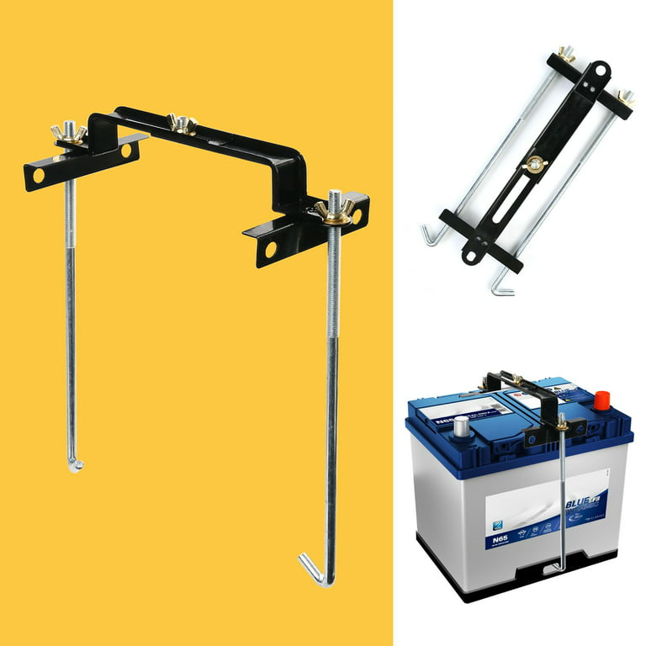
* Working Seat belt for each occupant. Seat belts must remain fastened when vehicle is in motion during ride.

**Ride Ratings and needed additional equipment (all rigs still need the minimum items above) If you have questions on a group rating please ask.** 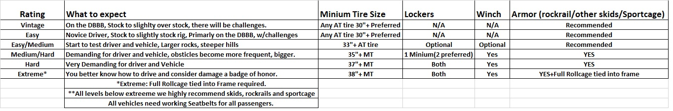

* **Tires: Metric/ Standard tire size chart: We know that A. Tire sizes are never true to the sidewall marking. B. That metric tires sizes can get confusing. At tech inspection we will use multiple methods to verify your tire height. The default will be what is listed on your sidewall and we will use logic and reason in making any tire size calls with respect to group requirements.**

**Popular tire sizes**

|  |  |  |
| --- | --- | --- |
| **Metric Tire Size** |  | **Inch Equivalent** |
| [255 / 85 R 16](https://amzn.to/3hY2kWM) | = | 33 x 10.0 - 16 |
| 285 / 75 R 16 | = | 33 x 11.0 - 16 |
| [285 / 70 R 17](https://amzn.to/3MybQhg) | = | 33 x 11.0 - 17 |
| [275 / 65 R 20](https://amzn.to/3t1jrxm) | = | 33 x 11.0 - 20 |
| [305 / 70 R 16](https://amzn.to/3IWznGu) | = | 33 x 12.0 - 16 |
| [305 / 65 R 17](https://amzn.to/3KzbDbM) | = | 33 x 12.0 - 17 |
| [305 / 55 R 20](https://amzn.to/3J0MQNr) | = | 33 x 12.0 - 20 |
| 315 / 65 R 17 | = | [33 x 12.5 - 17](https://amzn.to/35Npf4z) |
| 325 / 50 R 20 | = | [33 x 12.5 - 20](https://amzn.to/3vXkErm) |
| [285 / 75 R 17](https://amzn.to/3vWcuzf) | = | 34 x 11.5 - 17 |
| [315 / 70 R 17](https://amzn.to/35Q4lBL) | = | 34.5 x 12.5 – 17 |
| [315 / 75 R 16](https://amzn.to/3hYxGwi) | = | 35 x 12.5 - 16 |
| 310 / 75 R 17 | = | [35 x 12.5 - 17](https://amzn.to/3MJ1NX0) |
| 315 / 60 R 20 | = | [35 x 12.5 - 20](https://amzn.to/3Myevrg) |
| 315 / 80 R 17 | = | [37 x 12.5 - 17](https://amzn.to/3vTr0YH) |
| 315 / 70 R 20 | = | 37 x 12.5 - 20 |

**What Radio will be using to communicate on the rides?**

* + - We will be using GRMS Radios. Note there may be some overlap in channels but as the groups spread out this should not be an issue**.**

**Do I need to sign up for two different groups if riding both days?**

* + - * Yes, if attending both days you will need to pick a different group on Saturday than you did on Friday as otherwise that same group will run the same trails from the day prior. Please read the route descriptions under the groups to see which ones they plan to run. Note the listed routes are subject to change due to unforeseen circumstances such a weather or trail maintenance at the time of the event.

**Will I see the same trails each day?**

* We will try to make sure you see different trails/route, but cannot guarantee this as we try to get as many groups on the popular ones, so there can be some slight overlap on occasion. Please read the route descriptions under the groups to see which ones they plan to run. Note the listed routes are subject to change due to unforeseen circumstances such a weather or trail maintenance at the time of the event.

**Can I sign up for two different group difficultly levels over the weekend?** –

* YES: Make sure your rig meets the requirements for each group difficulty level.

**Can my buddy ride in my group if we both meet the minimum requirements?**

* YES, however we can't guarantee this as each group has a maximum number of rigs. Try to sign up online at the same time for the same group to improve your chances of success.

**Is there an age requirement for Drivers?**

* All drivers must be at least 18 years old and have a valid driver’s license.
* There is no age restriction on passengers, however if under 18 a Parent or Legal guardian must be in attendance.

**Can my buddy ride in my group if I meet the requirements and they don’t?** -

* NO. We recommend that you sign up for the group that your buddy's rig meets the requirements for.

**Do I need to pack a lunch? -**

* YES: Most rides will get back sometime between 3-5pm. We do not exit the woods for lunch. We recommend packing extra drinks and food, in case the ride would last longer than expected. No alcoholic beverages or mind-altering substances are permitted.

**Could my vehicle be damaged**?

* Every effort is made to keep this event as safe as possible. Our guides will do their best to get you past any difficult sections. However, there is always the chance of some damage when traveling on rough terrain. At a minimum you should expect your vehicle to be dirty, to make contact with any overgrown brush along the route. In addition, any low hanging points such as but not limited to, skid plates, frame rails, and other vehicle low areas may make contact. The harder the group rating the increased chance for possible damage there is. Any damage is the responsibility of the owner. If any of this is a concern for you then you may not want to attended.

**What happens if I break down?**

* If it is a quick fix, we will do our best to get you back up and moving. If the breakdown is major, we will do our best to get your rig back to Hollerwood Park so you can make arrangements for pickup. If you need parts and can't get your rig out of the woods on your own, we will try our best to help you get out of the woods and get your rig fixed. WE WILL NOT LEAVE YOU OR YOUR FAMILY IN THE WOODS OVER NIGHT, AND WE WILL TAKE YOU BACK TO A SAFE PLACE OF LODGING.

**Where can I stay?:**

* There are a number of options for lodging in the area: below are just some of the you may want to consider:
* [Where To Stay | Powell County Tourism (gopoco.org)](https://gopoco.org/where-to-stay/)
* [Ryders Ranch Campground](https://www.rydersranchcampground.com/)
* [Natural Bridge Campground: Red River Gorge Campground in KY](https://naturalbridge.camp/)
* [Explore | Natural Bridge State Resort Park (ky.gov)](https://parks.ky.gov/explore/natural-bridge-state-resort-park-7796)
* [4 Guys RV Park Stanton Kentucky | RV Campground Red River Gorge](https://www.4guysrvpark.com/)
* [Home | Lil Abners Motel in Slade, KY](https://lilabnersmotel.com/)
* [Lago Linda Hideaway - Cabins, Camping & RV Camping](https://lagolinda.com/)

**Can I bring my Dog?:**

* Service animals are fully welcomed.
* Very well behaved, leashed dogs are permitted. If your dog does not do well around strangers, kids, or large crowds then don’t bring it.
* Please cleanup after your pet.
* You are responsible for the actions of your pet, plan accordingly.
* You should also have a way to secure your dog such as a harness while in the vehicle.

**No Alcohol or legal or illegal mind-altering substances are permitted**.

* Operation of a motor vehicle is a serious matter if we believe/determine/suspect that you are under the influence you will be asked to leave and barred from any future events.
* In addition, no alcohol/substances are permitted at the Friday night dinner or raffle.

**What if the Weather is bad?**

* The event will take place rain or shine. Please check the forecast so you know what to expect before you arrive.

**What is the refund policy?**

* No Refunds, all sales are final.
* Please be aware our no refund policy is based on the many business partners for the event to whom we pay deposits or make commitments based on a preliminary participant count. However, we realize life happens and unexpected events such as true emergencies may cause you to be unable to attend. Therefore, if some sort of valid emergency comes up that will prevent you from attending (seasonal weather is not a valid reason) we will on a case-by-case basis determine if we are able make some type of partial refund.
* At the very minimum we will officially let others know you have valid event tickets so that someone else may be able to purchase your tickets from you.
* If you see tickets being resold and we have not made an official post confirming the tickets are valid, it is most likely a scam post.

**Waivers:**

* For this event we will ask you to fill out and sign several waivers for those who are riding in your vehicle. These are required by our event partners.
* Waivers will be available on the site closer to August 1st, to review and will be part of the check out process, please print out and bring with you.
* Waivers will be turned in on site Hollerwood. (see below map)

Traffic flow and group line up at Hollerwood park:

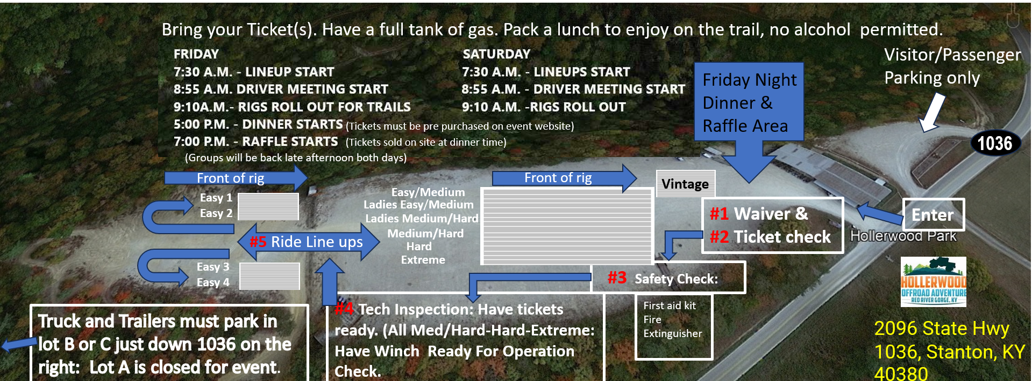

Information above subject to change without notice.

END FAQ rev 7/17/2025